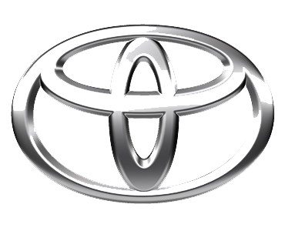
undefined
TOYOTA MOTOR CORPORATION
I. TOYOTA-CHO TOYOTA. AICHI, 471—8571(HEAD OFFICE)
or 471 8572 (Research 5 Development Group) THAILAND
TEL: +81-565-28-212

GSO Conformity Certificate CCR No. 213472
Motor Vehicles
Manufacturer: Toyota Motor Corporation
Country of Origin: JAPAN, Country of Production: JAPAN
To: GCC Standardization Organization (GSO)
We hereby certify that the vehicles manufactured by Toyota Motor Corporation
* Type: Toyota Land Cruiser Prado GDJ250 2.8L Diesel SUV 4WD 5Doors
* VlN number: JTEARCAJ*S*******
* Model Year: 2025 * Produced in and after: Month 8 Year 2025
* Category: SUV
Will satisfy the G50 Technical Regulations Nos: 34:20o7, 3s:2007, 36:2005, 37:2012, 38:200s, 392005, 40:2011,42:2015, 48:1984, 51:20o7, 52:2007, 53.2007, 9611988. 9721988, 9811988, 9921988,13522007, 13622007. 29021994. 4119:1994,42o:1994,421:2005,422:200s.1040:20001041:2000,1042:2000,1053:2000,1503:2010,1598:2002,1624:2002,1677:2003,1708:2o0s,1780:2010,1781:2006,1782:2008,1783:2006,1784:2o0e.Gsolso1585:2008,GSO lSO 3537:2008, GSO 150 3538:1997, G50 ECE13H:2012,GSO ECE13H-1:2012,GSO ECE13H-2:2012,GSO ECE 13H-3:2012, GSO ECE13H-4:20l2, GSO ECE13H-S:2012,GSO ECE 13H-6:2012 and the standards in the country of origin accepted by GSO in the case that no GSO technical regulations and standards are available.
All the essential technical data are as follows:
1. Weights
a. Maximum Vehicle Weight: 3100 kg b. Curb: 2490 kg
c. Maximum Axle Weight: Front: 1605 kg Rear: 1860 kg
2. Dimensions
a. Length: 4990 mm b. Width: 1940 mm
c. Height: 1940 mm d. Wheelbase (Fl R1) 2850 mm e. Track: Front: 1664 mm Rear: 1664 mm
3. Type of chassis and body: Body-on-frame
4. Number of Passengers: 7(Including the Driver)
5.Engine: Diesel a. Cylinders: 4 b. Displacement: 2755cc c. Air intake: Turbo
d. Net Engine Power: 150 kW at 3400 rpm Pollutant Limit comply with Euro 4.
6. Transmission: Automatic

7. Brakes a. Service Brakes: Hydraulic b. Emergency Brakes: Combined with the service brake
8. Fuel Economy a. Motor Vehicle Class: Multipurpose Vehicle b. FE (CAFE) Combined: 14.1.7 km/L - Excellent
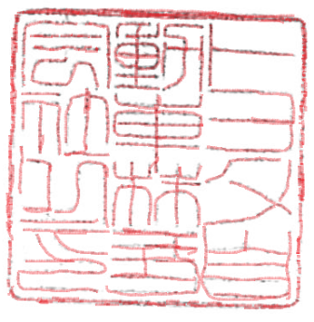
9. Any other information or local standards to be compiled: Also comply with the National regulations for member countries mentioned in the Annex of the list of Technical Regulations for MV 2025 MY-D5, when exporting to those countries. for member countries mentioned in the Annex of the list of Technical Regulations for MV 2025MY-D3, when exporting to those countries. for member countries mentioned in the Annex of the list of Technical Regulations for MV 2025 MY-D3, when exporting to those countries.
Keiko Yanagi
17 SEP 20252025
general Manager Regulation &Certiﬁcation Division

